**Practical No. 1**

**Aim: Google and Whois Reconnaissance**

**Theory:**

Reconnaissance is a set of processes and techniques (Footprinting, Scanning & Enumeration) used to covertly discover and collect information about a target system. Reconnaissance takes place in two parts :-

Active Reconnaissance and Passive Reconnaissance.

**Active Reconnaissance:**

In this process, you will directly interact with the computer system to gain information. This information can be relevant and accurate. But there is a risk of getting detected if you are planning active reconnaissance without permission. If you are detected, then system admin can take severe action against you and trail your subsequent activities.

**Passive Reconnaissance:**

In this process, you will not be directly connected to a computer system. This process is used to gather essential information without ever interacting with the target systems.

**Step 1:** Search <https://who.is> on browser.

**Step 2:** Search [www.tcs.com](http://www.tcs.com) on whois website.

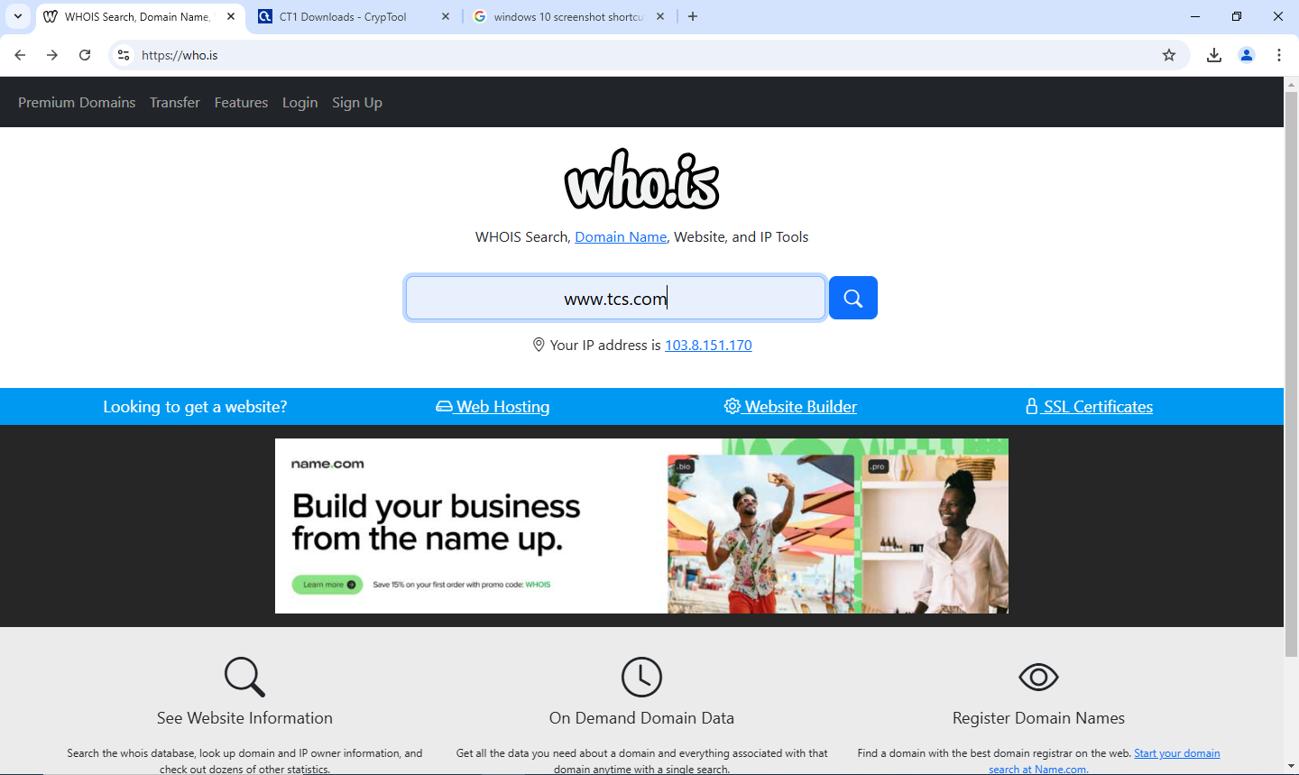

**Step 3:** Click on diagnostics and complete i am not robot procedure.

**Step 4:** You will get ping as a result.

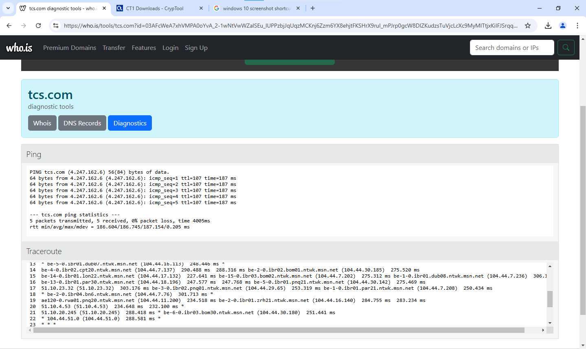

**Practical No. 2**

**Aim: Password Encryption and Cracking using CrypTool.**

**Step 1:** Download CrypTool:

<https://www.cryptool.org/en/ct1/downloads/SetupCrypTool_1_4_42_en.exe>

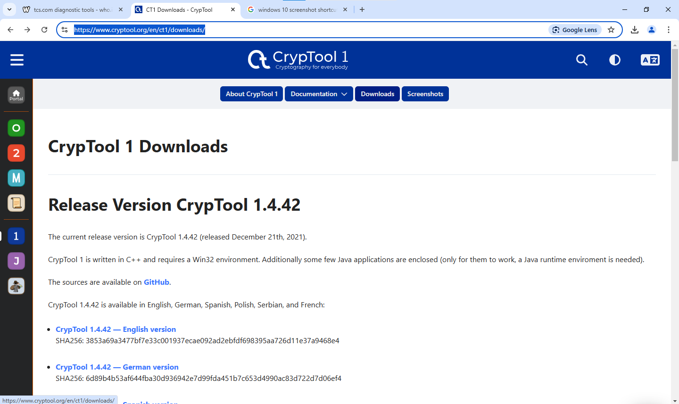

**Step 2:** Install it by default options.

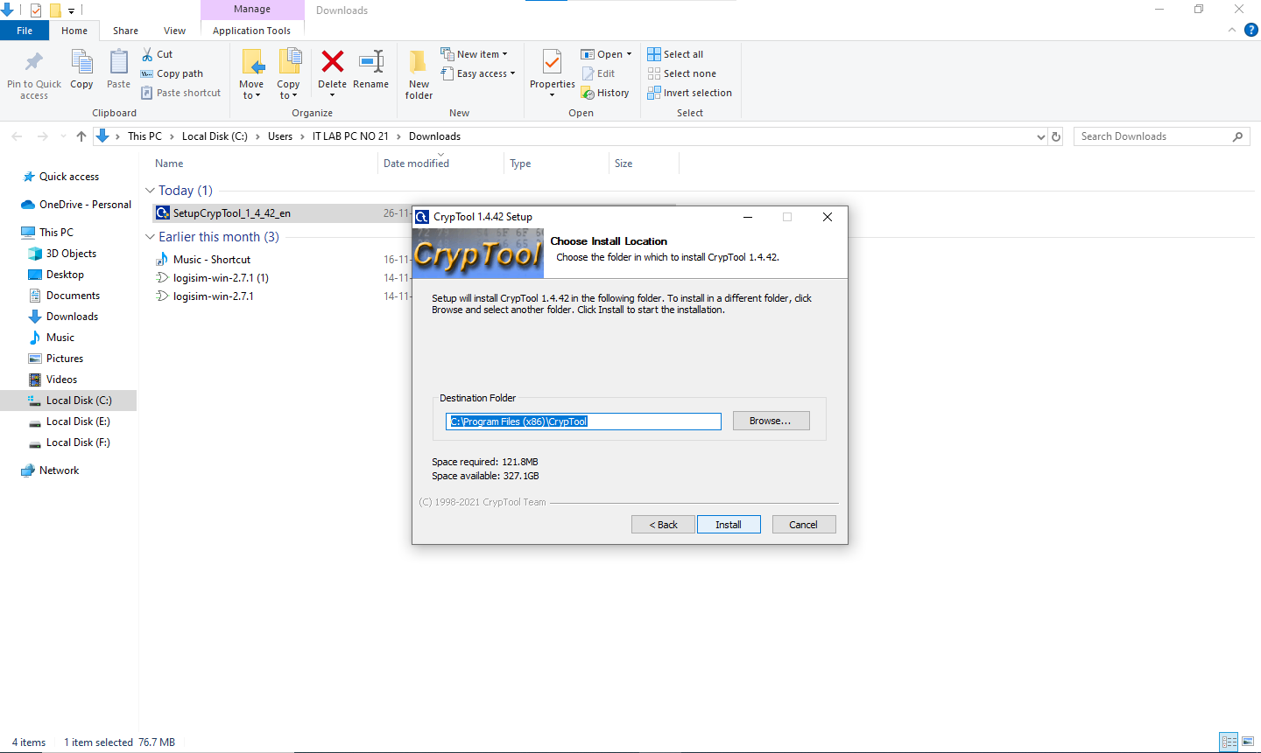

**Step 3:** Run crypTool and remove all the default text from the window.

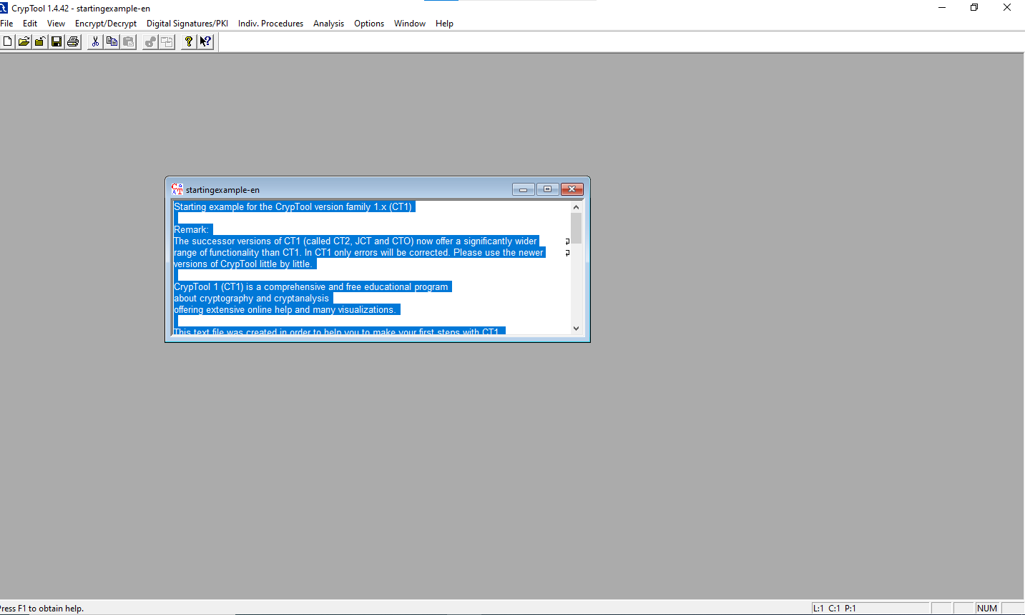

**Step 4:** Now enter any text that you want to encrypt.

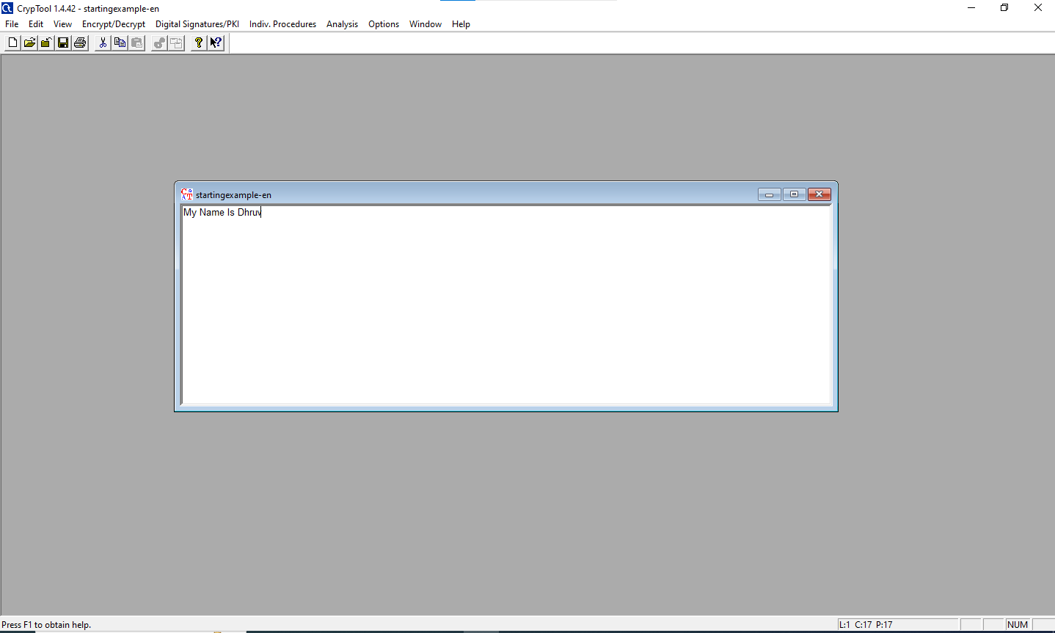

**Step 5:** Now go to encrypt/decrypt menu and then symmetric modern.. then select your algorithm.

AES Encryption:

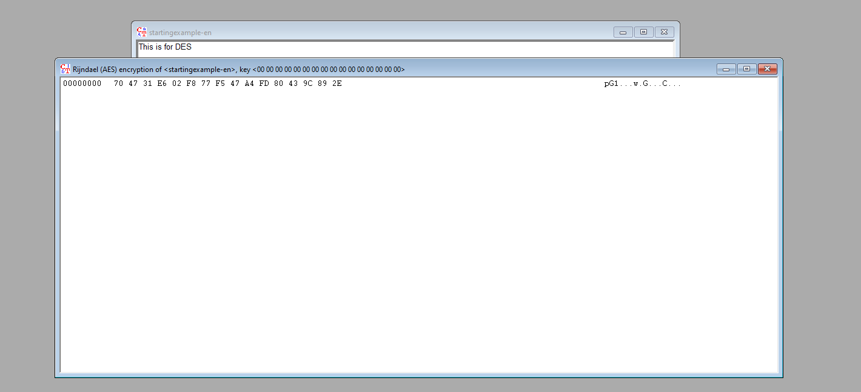

AES Decryption:

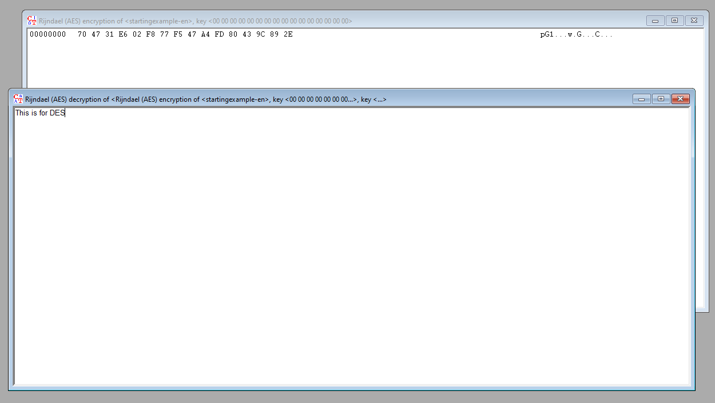

DES Encryption:

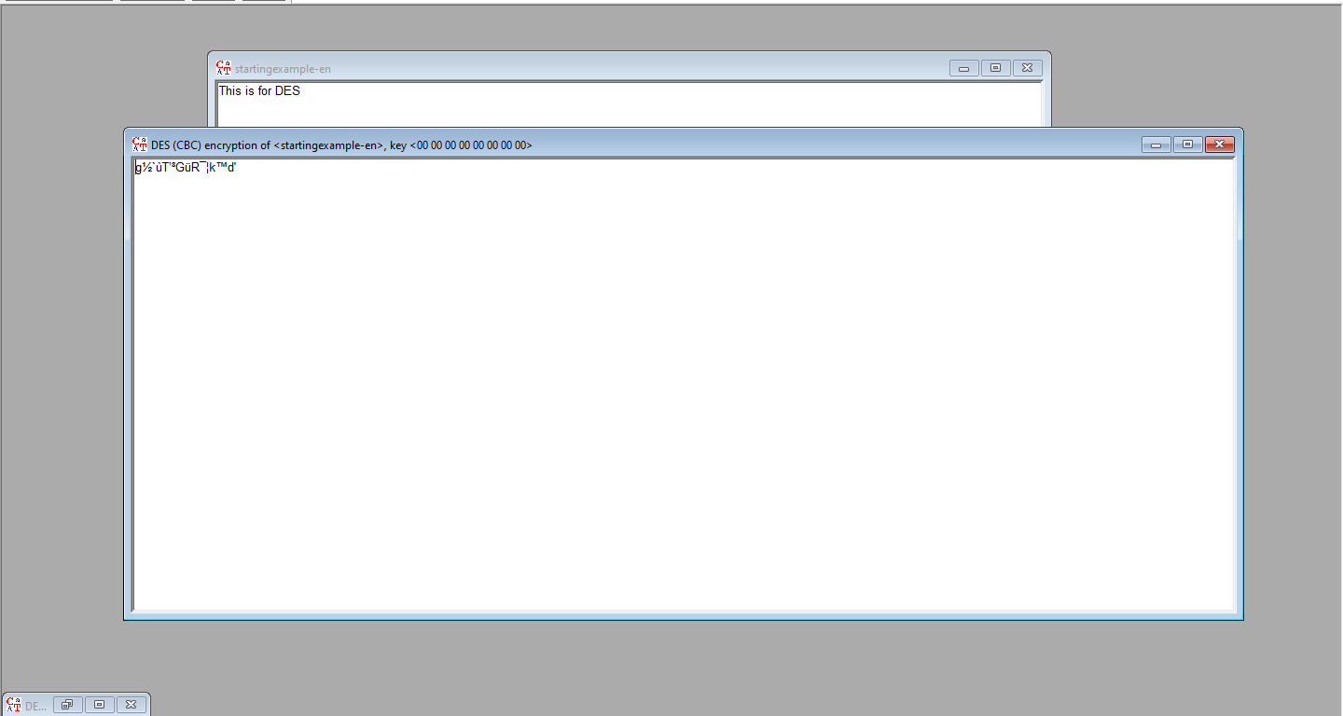

DES Decryption:

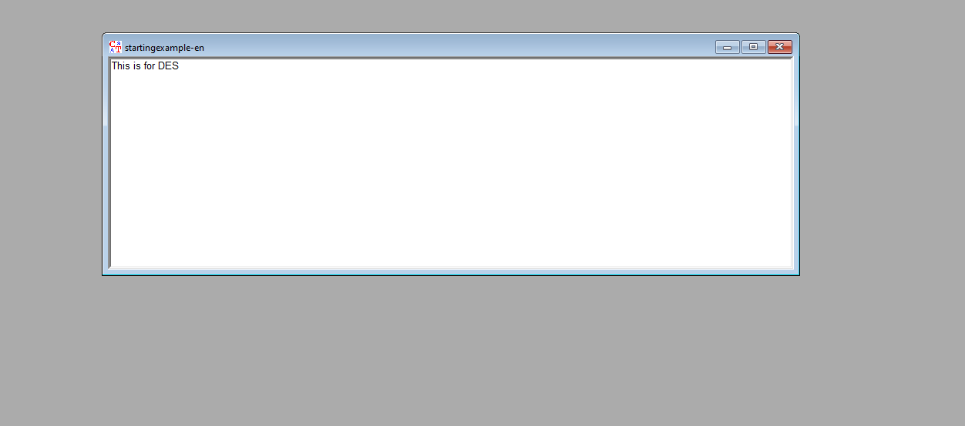

RC4 Encryption:

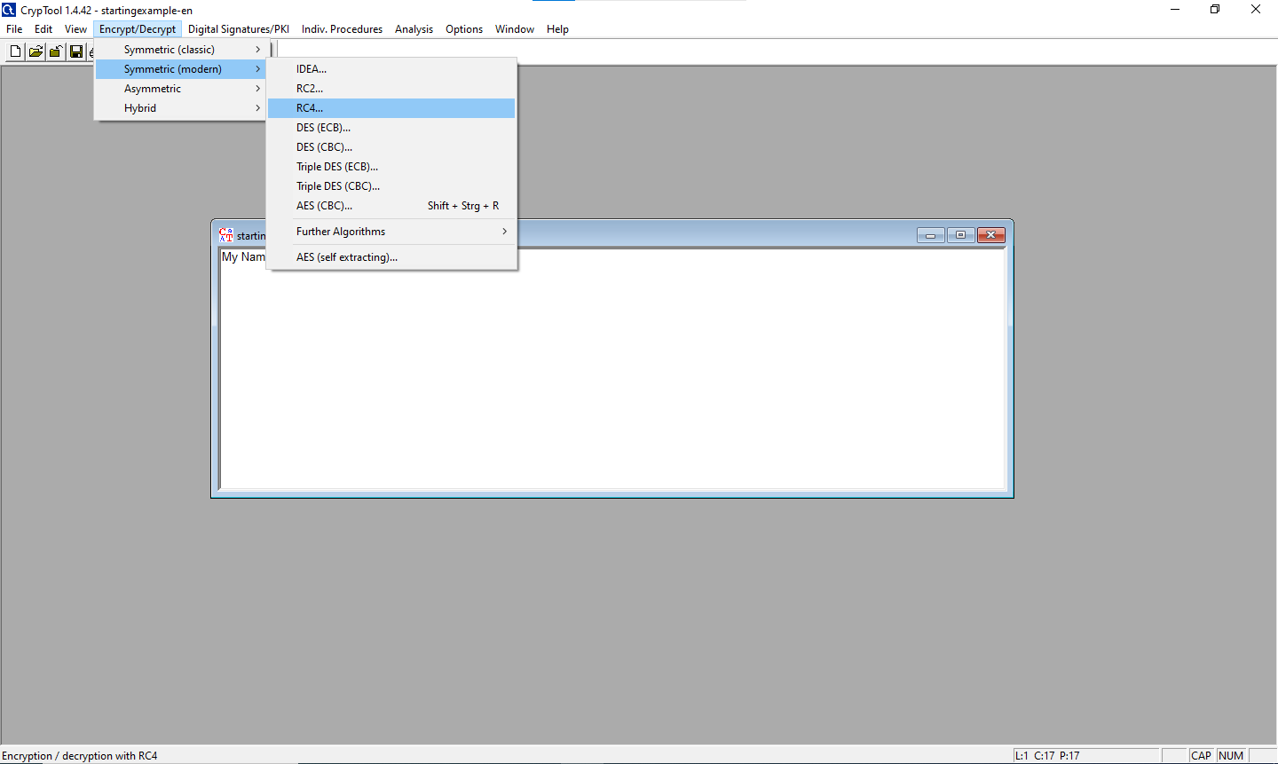

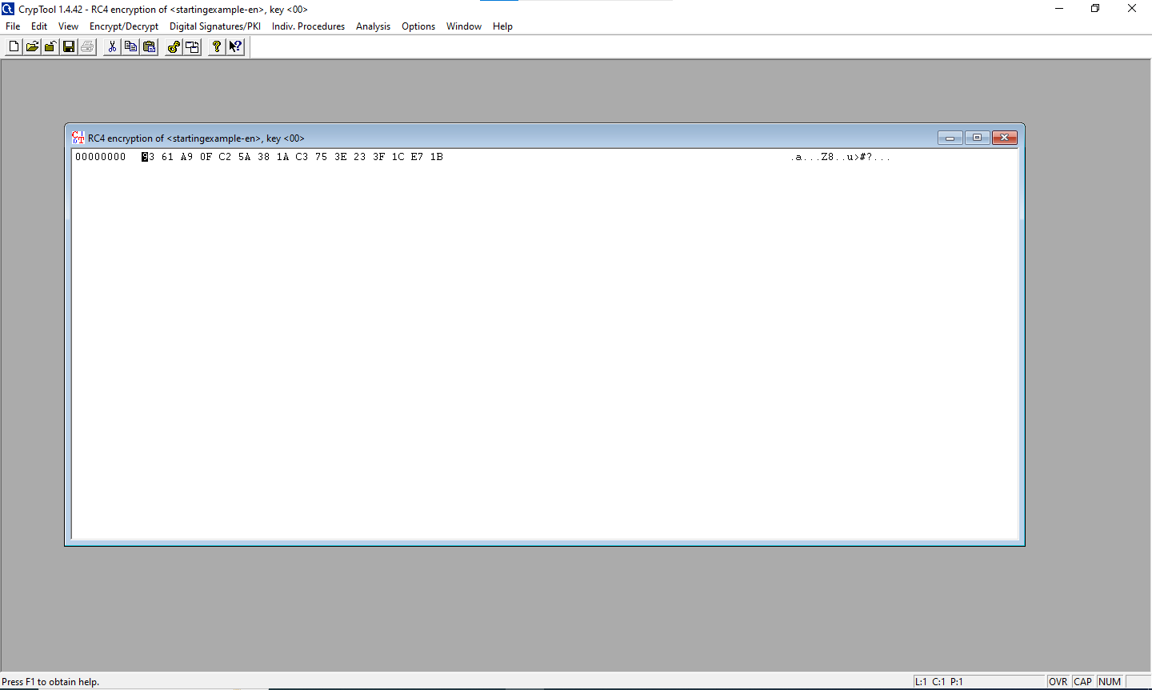

RC4 Decryption:

